Module 10: Get started with computer vision in Azure

Understand Azure AI services for computer vision
- Azure AI Vision service provides prebuilt and customizable computer vision models that are based on deep learning models and provide various capabilities.
- This service contains many products, but the most common are:
  - Azure AI Vision Image Analysis service:
    - Detects common objects in images, tags visual features, generates captions, and supports optical character recognition (OCR).
    - Example: Man holding a surfboard
      - 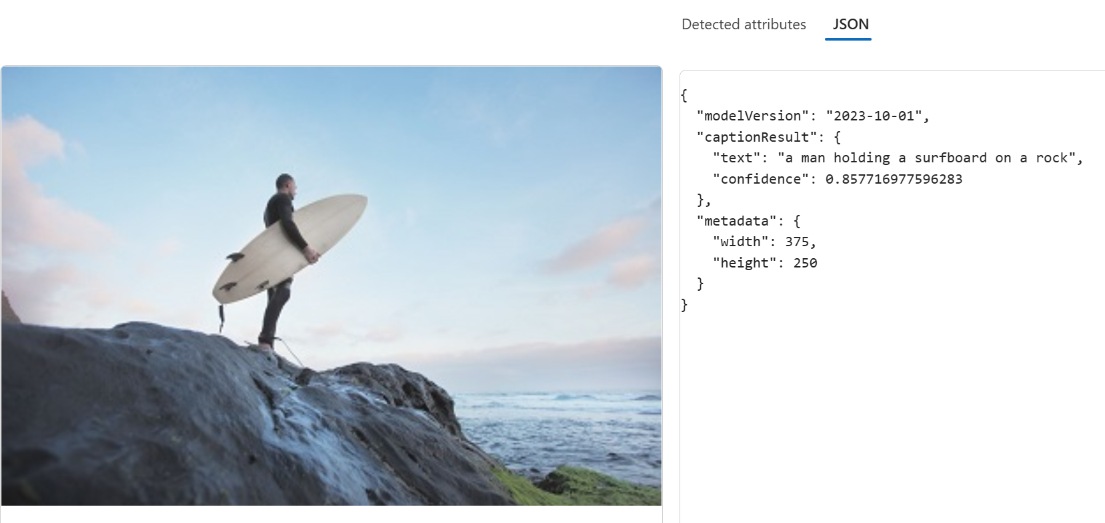
  - Azure AI Face service:
    - Detects, recognizes, and analyzes human faces in images.
- Others include:
  - Search engine optimization – use image tagging/captioning for improvements in search ranking.
  - Content moderation – use image detection to help monitor the safety of images posted online.
  - Security – facial recognition in building security apps and operating systems for unlocking devices.
  - Social media – facial recognition can be used to automatically tag known friends in photographs.
  - Missing persons – use public cameras systems to identify if a missing person is in the image frame.
  - Identity validation – useful at ports of entry kiosks where a person holds a special entry permit.
  - Museum archive management – using optical character recognition to preserve information from paper documents.

Understand Azure AI Vision Image Analysis capabilities
- Azure AI Vision's image analysis capabilities can be used with or without customization.

A) Capabilities that do not require customization

Describing an image with captions
- Analyze an image, evaluate the objects in it, and generate a human-readable description of the image

Detecting common objects in an image
- Identify thousands of common objects in images.
  - Ex. detect objects in the skateboarder image, Azure AI Vision returns the following predictions:
    - Skateboard (90.40% confidence score) & Person (95.5%)
- Azure AI Vision returns bounding box coordinates of the object detected (coordinates determine where in the image each object was detected)

Tagging visual features
- AI Vision can suggest tags for an image based on its contents (Tags are metadata of the image).
  - The tags summarize attributes of the image which can then be used to index an image along with a set of key terms for a search solution.

Optical character recognition
- Use optical character recognition (OCR) capabilities to detect text in images.
  - Ex. AI Vision can analyze the image of a nutrition label on a product in a grocery store and extract the nutritional facts

B) Training custom models
- You can use the service to train a custom model for image classification or object detection. They are built with foundational models

Image classification
- Used to predict the category, or class of an image.
  - Example: Detect type of fruit based on an image

Object detection
- Used to detect and classify objects in an image, returning bounding box coordinates to locate each object.
  - Example: use photographs of fruit to train a model that detects multiple fruits in an image

Understand Azure AI Vision's Face service capabilities
- Azure AI Face can be used for use cases such as verifying user identity, liveness detection, touch less access control, and face redaction

Facial detection
- Identifying regions of an image that contain a human face (often returning bounding box coordinates)
- Facial features can be used to train ML models to return other information
  - Such as facial features such as nose, eyes, eyebrows, lips, and others.

Facial recognition
- Identify known individuals from their facial features (uses multiple images of an individual to train the model).

Other Azure AI Face service capabilities
- This service can return facts as well as other related attributes:
  - Accessories: whether the given face has accessories.
  - Blur: how blurred the face is
  - Exposure: whether the image is underexposed or over exposed
  - Glasses: whether or not the person is wearing glasses.
  - Head pose: the face's orientation in a 3D space.
  - Mask: indicates whether the face is wearing a mask.
  - Noise: refers to visual noise in the image (ex. photo with a high ISO setting for darker settings)
  - Occlusion: determines if there might be objects blocking the face in the image.
  - Quality For Recognition: a rating of high, medium, or low for whether the image is of sufficient quality to attempt face recognition on.

Get started in Azure AI Foundry portal
- Azure AI Vision: A specific resource – use this resource type if you don't intend to use any other Azure AI services, or if you want to track utilization and costs for your Azure AI Vision resource separately.
- Azure AI services: A general resource that includes Azure AI Vision along with other Azure AI services. Use this resource type if you plan to use multiple AI services and want to simplify administration and development.

